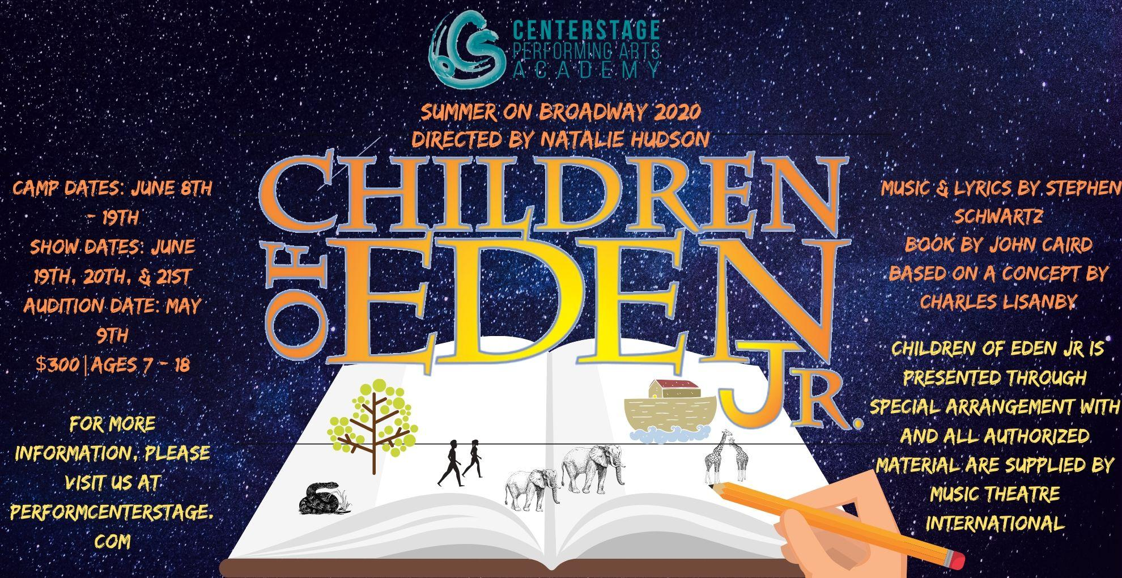
Dear Parents and Campers,

We are so excited to work with you this summer. Every single one of you is so important, and an integral part of our cast.

Covid 19 Protocol:

To keep our performers safe during rehearsals and performance, CenterStage will be implementing the following:
- Sanitizing all surfaces, doors, and thresholds of all classrooms and rehearsal spaces every hour
- Providing students with hand sanitizer and regular breaks to wash their hands
- Students should bring their own snacks and water bottles and not share with others
- We will be asking all of our patrons to wait outside the building until the house opens. At this time, both lobby and theatre doors will be open. We ask that patrons not linger or hang out in the lobby
- Limiting our audience to 150 attendees per night. Chairs will be sanitized in between shows
- We ask that all of our patrons give quick waves to their performers and exit the building upon the end of the show
- We encourage families of performers to pick their students up or go out to eat in between shows, giving the CS staff to fully sanitize all dressing rooms

Important Dates:
- Auditions (optional) May 9th
- Rehearsal dates:
First Week June 8th – 13th 1:00 – 6:00 PM
*Extended Rehearsal June 12th 1:00 – 7:00 PM *mandatory
Second week June 15th – 18th 1:00 – 6:00 PM
*Extended Rehearsal June 18th 1:00 – 7:00 PM *mandatory
Final Rehearsal June 19th: 10 am - 4:00 PM
- Show dates:
June 19th, 7:00 PM (5:30 Call)
June 20th, 2:00 PM (12:30 Call)
June 20th, 7:00 PM (5:30 Call)
June 21st, 2:00 PM (12:30 Call)
June 21st, 7:00 PM (5:30 Call)
- All rehearsals and performances will be located at CenterStage Performing Arts Academy.

Costs:
- $300.00
- Parents should be prepared to provide dance shoes, attire for under costumes, and stage makeup ($25 - $100)
- Due to Covid 19, extensions on payment can be made! Payments are due in full by June 5th.

Auditions (Optional):
All students who enroll in Children of Eden Jr will have special chorus roles, and will be featured in ensemble dance and musical roles. Any students interested, have the option of auditioning for a speaking part/lead role in the show. Only students who audition will receive a speaking part/lead role.

Students auditioning for Adam and Eve will be asked to sight read harmonies from the musical. Please be familiar with The Naming and Ring of Stones and prepare to sight read other material.

Audition Info:

When: May 9th, 2020

Where: CenterStage Performing Arts Academy
250 Hancock St. Gallatin, TN 37066

Cost: $30 Tuition Deposit (non-refundable) due at time of audition. This deposit will be counted towards the full tuition.

Auditions will be by appointment. Only one student will be allowed inside the building at any given time. Please arrive fifteen minutes early. Please plan to leave immediately upon finishing the audition. Please sign up here.

Tickets:
- $10.00 Adults
- $8.00 Kids 10 under
- $8.00 Seniors 60+
- $8.00 Military

*Tickets: Tickets go on sale Saturday, June 13th at 1 p.m. at performcenterstage.eventbrite.com.
$10 for adults
$8 kids aged ten and under
$8 for seniors 65+
$8 for active military (thank you for your service) $0 kids aged 4 and under (must sit on a lap)

Purchasing tickets online:
-using a computer, you are able to select your assigned seat
-using a cell phone or tablet, you will automatically be assigned the best available seats
-tickets will be emailed to you
-you do not need to wait in line to purchase tickets, or enter the theater on show day
-ticket availability is guaranteed
-tickets will have an additional surcharge of around $2 per ticket
Purchasing tickets at the door (available at CenterStage, 1 hour before the show begins):
-tickets can be purchased with cash or credit card
-you will not be able to select your assigned seat. All tickets purchased at the door will automatically be assigned the best available seat
-if you are attending the show with others who purchased tickets ahead of time, you will not be able to sit together
-ticket availability is not guaranteed
-if purchased with cash, there will be an additional $1.00 fee
-if purchased with credit card there will be a $0.30-$0.80 charge added to your order (not per ticket)
If you do not purchase tickets before the show day, we cannot guarantee availability. If you need assistance purchasing tickets, please stop by the front desk during regular business hours or email info@performcenterstage.com. All tickets purchased ahead of time, either online or in person will be subject to the surcharge.
Refunds:
No refunds will be issued the day of the show. Please organize payment and attendance with your party ahead of time.
Tickets cannot be transferred from seat to seat or show to show. You will need to request a refund and note the seat you would like to refund.

Leading Roles: Leading roles and minor characters will be assigned May 12th, after auditions. Students should spend the remainder of the month, memorizing all music and lines. Leads are expected to be off book by 1st day of rehearsal. Leads should also be prepared to have morning rehearsals from 10:00 AM – 12:00 PM June 8th – 12th and the 15th – 19th, to work on solos and blocking. Official rehearsal schedule TBA.

Rehearsal Info: We will begin June 8th, at 1:00 PM SHARP! Please come fifteen minutes early to confirm the proper forms are turned in, ie: registration, medical/photo release, etc. We will also have a sign in/out sheet. Students under the age of 16, will need to be signed in by a parent or guardian. This is for their protection and safety.

Snacks: Please make sure your camper has plenty of snacks and is well hydrated! We will give multiple breaks during the day. Students will also need to provide their own water bottle. The drinking fountains will be turned off due to try and keep our performers from spreading germs.

Dress: Campers need to come prepared in clothes they can move in: sweat pants, basketball shorts, and good tennis shoes. NO JEANS. Girls should wear something they are comfortable to dance in. Girls should not wear clothing that are too short, tops that are too low, etc. Hair should be pulled back and out of the face. If the camper has dance shoes, please bring those. No flip flops or bare feet please!

Costumes: Once we have met and assessed our entire cast (June 8th), we will email a cast list with each student and their part.
- Students may need specific shoes or tights for their role (these can be ordered through CenterStage or parents may choose to find them on their own)
- Students may be asked to come in/or go to Performance Studios in Nashville to be fitted for their costumes the week of June 1st.
- All costumes will be rented or purchased by CenterStage, and are CenterStage’s property. Students may not take costumes home with them.
- Parents should be prepared to provide dance shoes, attire for under costumes, and stage makeup. All girls who have costume changes must wear a leotard.

Cast Tee Shirts: All cast members interested in purchasing a cast tee shirt need to submit their order and payment no later than June 8th. The order will be placed on June 9th, no exceptions. Shirts are $25.00.

Rehearsal Materials: All music will be available through Google Drive, and emailed to the student after the first rehearsal. Copies of scripts will also be available for the students on the first day.

Rehearsal at home: Homework/private rehearsal is what separates amateurs from professionals. Students should come prepared for rehearsal mentally and emotionally. This rehearsal process is very fun and exciting but will also be demanding and strenuous. We expect that as campers go home every day, they will continue to practice and polish what they have learned. We will not have time to re-teach material. We will provide YouTube videos of choreography as soon as students have learned it so that they can practice at home. We also suggest bringing a voice recorder for learning parts, and a notebook for blocking and acting notes.

Tough Love: We can’t say it enough. EVERYONE is constantly auditioning. Hours of rehearsal and daily improvement is expected. If a student will not accept critique, comes in unprepared, or does not know their material, the directors may choose to give this role or solo to another student.

Zero Tolerance Policy: Many of our students choose to keep some extra money on them to be able to purchase concessions in between shows. If the child is responsible for purchasing their snack in cash, we ask that the students have their cash in an envelope and leave it at the front desk with the office manager or member of the production team during the show and come collect what they need to purchase their snack. We have had reports of lost or stolen money during a show. CENTERSTAGE HAS A ZERO TOLERANCE POLICY FOR STEALING. IF A STUDENT IS CAUGHT, THEY WILL BE EXPELLED FROM CENTERSTAGE INDEFINITELY.

Behavior Policy:

CenterStage students are expected to conduct themselves professionally, kindly, and with humility towards all CS staff and cast members. CenterStage believes in teamwork and everyone is truly important to the success of a production. In that spirit, our staff goes out of it’s way to never show favoritism. We expect all students to abide by the expectations stated above without exception. The production team and (ultimately) the director (s) have the final say on all aspects of a production. This includes changing staging, assignment of solos, or the order and content of the show.

When addressing a student’s behavior, CenterStage will always have at least two staff members present and hold the conversation behind closed doors or in private.

Directors usually give a student two - three opportunities to correct their behavior before bringing in the parent for a meeting. If the behavior is unsafe or of an urgent nature, the directors will act quickly and request a meeting with the parent and student.

Regarding parents, and all other concerned friends and family, we always welcome comments whether it be a “thank you”, comment, critique or concern. It is truly our desire to create the best production possible with the most favorable experience for every performer. We understand everybody wants their student to be “the star” front and center. We hope you all realize this is an impossible task from a director’s stand point. It is important that all involved understand the mammoth job every production is. Once rehearsals start, all staff is living, eating and breathing the work at hand, normally working very long hours with very little sleep. We use the talent available to perform the show as written, often making changes to choreography, song length, lyrics, etc. to create the best effect for every number in the show. If your student is part of the CenterStage Family, we assume that you trust our staff to make these judgement decisions without outside influence.

Noting the points above, we respectfully ask that all commentary be submitted in writing after the last performance. We will not have time to read, address and respond to your communication until possibly a week after the production has ended. We continue to “fine tune” the show throughout the performance schedule and often correct your concern as the schedule proceeds. Unless it is an absolute emergency (the director has final say on what an emergency is) requests for meetings will not be addressed until the week after the run of the show.

Extra help during the run: Moms and Dads! We are looking for extra help during the performances for the front of house.You will not be expected to be behind the scenes every single performance, but we are hoping you will volunteer enough to allow for a nice even rotation. Please let us know if this is something you can help us with!

Please don't hesitate to email us or call us if you have any questions. We look forward to working with you!

- The CenterStage Team

